**THE EFFECT OF LAVA FLOWS ON UNDERLYING SOILS: IMPLICATIONS FOR UNDERGROUND INFRASTRUCTURE IN AUCKLAND.** H. R. Taylor1 and S. W. R. Tsang2, 1Monash University, htay0012@student.monash.edu, 2Monash University, Sophia.tsang@monash.edu

**Introduction:** Auckland is New Zealand’s largest city and has a population of 1.7 million people, which is expected to rise to up to 2.8 million by 2048 [1].

In the past decade, Auckland has seen a significant shift towards underground infrastructure, with 72.3% of powerlines in Auckland being underground as of 2024 [2]. The aim of this change is to maximise land use and create more space to accommodate a growing urban population [3]. However, the potential impacts of natural hazards on this system have not yet been studied in detail.

The city of Auckland lies on the Auckland Volcanic Field, a province of monogenetic basaltic volcanoes that is considered active. The most recent eruption is estimated to have been 600-700 years ago, and although an eruption is considered unlikely on the human timescale, it would have significant consequences for the people living in the region [4].

The objective of the experiment was to understand the impact of lava flows on underlying soil substrates and therefore the potential impacts on underground infrastructure. The findings will ideally be applied to future hazard assessments in the Auckland Volcanic Field.

**Methods:** To project the cooling behaviour of the soils under the lava flows, an exponential decay equation was developed based on Newton’s law of cooling. This law states that the rate of temperature change in a system is directly proportional to the difference between the initial temperature and the ambient temperature. This was written in python as:

def cooling_model(t, T_ambient, T_initial, k):

    return T_ambient + (T_initial - T_ambient) * np.exp(-k * t)

The ambient and initial temperatures were based on the minimum and maximum values in the data array, and the k was derived by visually matching the model to the data. The projection extended to 30 hours.

Finally, a function was created to show the time it took to cool from 800ºC to 200ºC on each graph.

x_above_800 = time_extended[np.where(temperature_projectedwet < upthreshold)[0][0]]

x_below_threshold = time_extended[np.where(temperature_projectedwet < threshold)[0][0]]

differencex = x_below_threshold - x_above_800

This created a boolean array to find the first x value where the y value falls below 800ºC and 200ºC, respectively. For example, the wet soil fell below 800ºC after 0.6 hours and fell below 200ºC after 6.73 hours. The difference, defined as *differencex*, was annotated on each graph.

To create heatmaps, time intervals were first selected by assigning the time column into bins and adding a new ‘Time Interval’ column to the array.

A temperature matrix was then made by finding the mean value in each time interval for each depth column, assigned the value “depth_columnswet”. It then creates a DataFrame with each mean value, using the following code:

temperature_matrixwet = wetvdry10.groupby('Time Interval')[depth_columnswet].mean()

The matrices are then converted into numpy arrays to allow for future numerical computations.

The problem with these matrices in their current forms, which wasn’t discovered until after plotting, is that they were in the wrong orientation, as the time interval values were rows and the soil depths were columns in the original DataFrame.

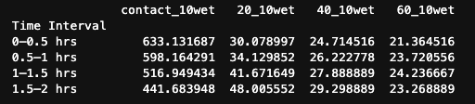

This meant that, although the time was marked on the x-axis and the depth was marked as the y-axis on the heatmap, the data for each depth was plotted as a column. This was solved by transposing the numpy array to the correct orientation.

**Results:**

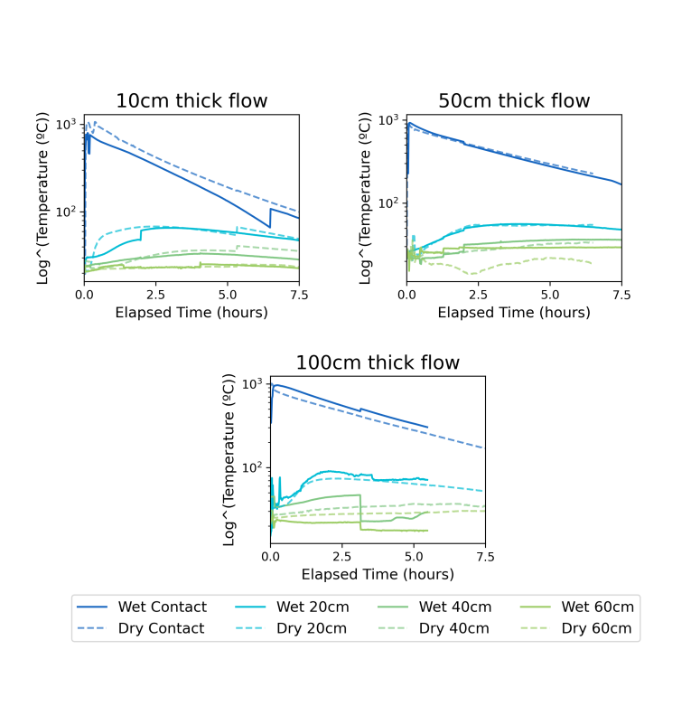

Figure 1: Time series of soil temperature under varying lava flow thicknesses.

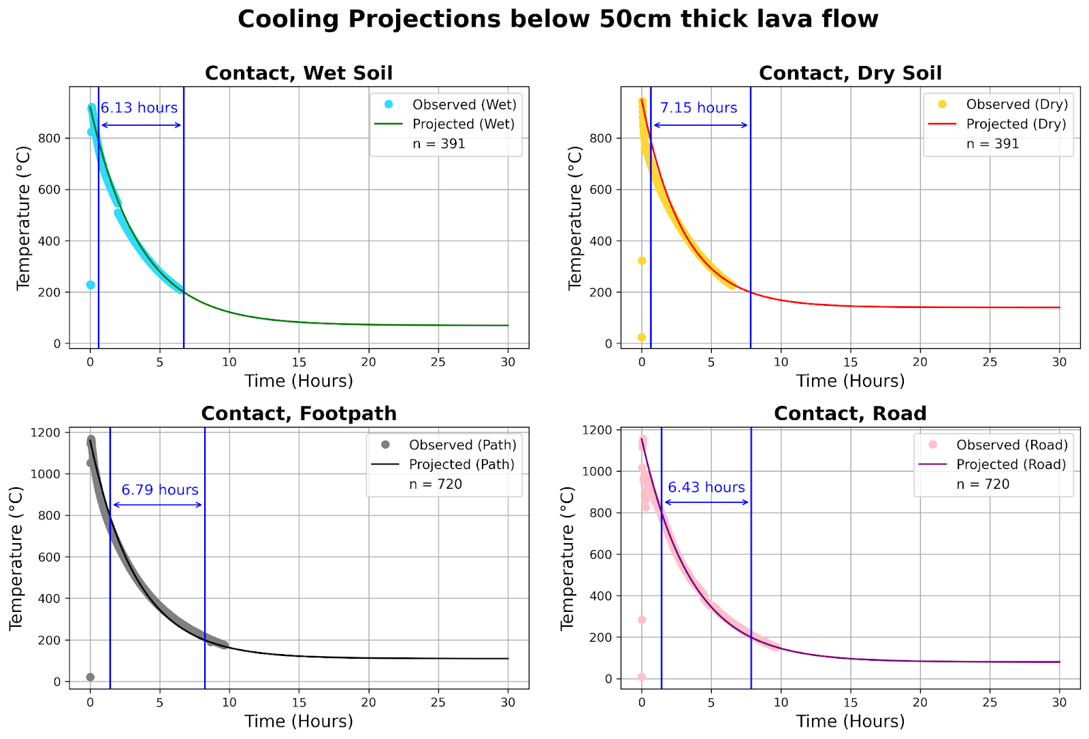

Figure 2: Temperature projections of the contact soil under a 50cm lava flow. The wet soil cooled from 800ºC to 200ºC the fastest, and the dry soil took the longest.

Figures 3-5: Temperature heat maps for the soils under varying lava flow thicknesses. The temperature is a log scale.

**Discussion:** The footpath took the longest to cool down to 200ºC from its initial temperature, however the footpath and road’s initial temperatures were higher than the soils. This was likely due to the variability in the speed of the lava being poured or changes in ambient temperature, as the experiment was performed outdoors [5].

The wet soil’s contact cooled down the fastest, and the dry soil’s contact took the longest to cool. This is likely due to the evaporative cooling capacity of the wet soil, whereby water evaporation absorbs heat from its surroundings and lowers the temperature [6]. On the other hand, the wet soil’s 60cm depth appeared to have a slight warming trend on the 10cm and 50cm heatmaps, whereas the dry soil either cooled or didn’t change. This is likely due to the thermal conductivity of the wet soil, as thermal conductivity tends to be higher with a higher initial soil moisture content [7]. The warming of the dry soil was focused in the contact and 20cm layers, with a more pronounced and enduring temperature spike, whereas the wet soil had a slightly lower temperature spike in the upper layers and appeared to transfer heat more effectively to the lower layers. This is more difficult to see in the time series graphs, as the series are plotted over a longer timescale, but the 50cm graph shows the deeper layers of the wet soil getting warmer than the deeper layers of the dry soil after approximately 2 hours.

These findings highlight the need for mapping soil moisture distributions across Auckland to be integrated into Auckland’s infrastructure planning. They inform the development of buried infrastructure capable of withstanding persistent thermal stress. Underground infrastructure in moisture-retentive soils - that will therefore transfer heat to deeper substrates more efficiently - will possibly need reassessment and adoption of more heat-resistant materials. This potential for mitigation will allow for the risk of heat-related infrastructure damage to be reduced after future eruptions. The methods used here could assist in assessing soil-lava interactions in other cities exposed to volcanic hazards.

**Code Availability:** The code and data used to create the graphs in this abstract are available at doi: 10.5281/zenodo.15093135

**Data Availability:** The original data and analysis are available at doi: 10.1007/s00445-019-1320-y

**References:** [1] Stats NZ (2021) *“Auckland Population May hit 2 million in early 2030s”* [2] Entrust (2016) “Undergrounding” https://rb.gy/d3nk9n [3] New Zealand Infrastructure Commission (2025) “Auckland’s infrastructure: The cost to serve a city that’s growing upwards” [4] GNS Science (2022) “New Zealand’s Volcanoes” https://rb.gy/236n79 [5] Tsang, pers. Comm., 24/3/25 [6] Givonni B (2007) *Solar Energy*, 81(3):316-328 [7] Gao et al. (2020) *Sustainable Cities and* Society, 55, 102069